* In class Exercise

% program 1 initial value from input

F_t=input('please input the F degree: ');

C_t=(F_t-32)*(5/9);

display(C_t);

% program 2: initial value from input

u_0=input('initial velocity: ');

u_0=150;

t=0:0.5:40;

g=9.81;

% calculate the vertical displacement

S_t=u_0.*t-(g/2)*(t.^2);

plot(t,S_t,'b--o');

% point-wise matrix operation

A1=[ 1 1 ; 2 3];

A2=[ 2 2; 2 1];

B=A1.*A2;

% change the matrix value by using ':' and find

A=floor(6*(rand(4,5)));

B=zeros(size(A));

ind=find(A>3);

B=A;

B(ind)=3;

v1=[ 10 12 14 16 18 20]';

v2=repmat(v1,1,4)

theta1=50:10:80;

theta=repmat(theta1,6,1)

g=9.8;

h=(v2.^2).*(sind(theta).^2)/(2*g);

* Homework

1

例如，要計算*z* = (*ey* sin *x*)cos2*x*，則要輸入

z = exp(y).*sin(x).*(cos(x)).^2

顯然，如果x的大小和y的大小不同，你會得到錯誤訊息。結果，z和x及y具有相同大小。

例如，p = [2, 4, 5]，則輸入3.^p會得到陣列[32*,* 34*,* 35] = [9*,* 81*,* 243]。

2

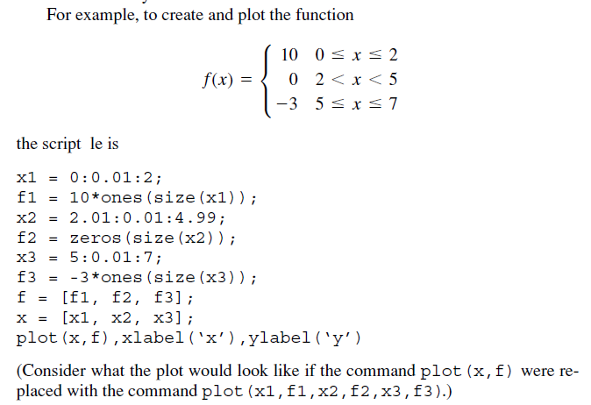

3

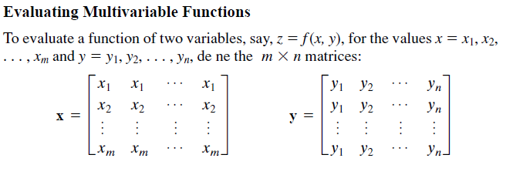

When the function *z* =*f* (*x, y*) is evaluated in MATLAB using array operations, the

resulting *m*\**n* matrix **z** has the elements *zij*= *f* (*xi , yj*). We can extend this technique

to functions of more than two variables by using multidimensional arrays.

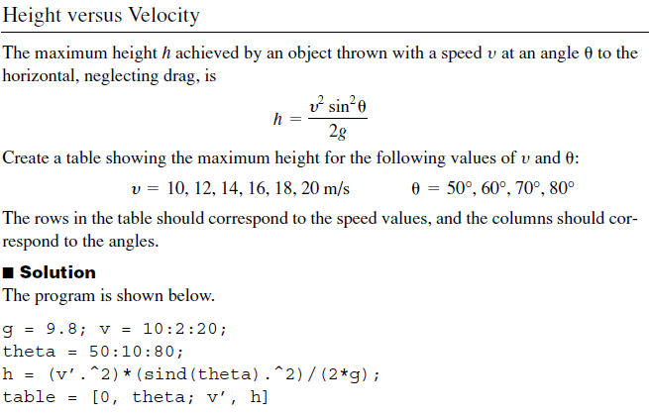

v1=[ 10 12 14 16 18 20]';v2=repmat(v1,1,4)

theta1=50:10:80; theta=repmat(theta1,6,1)

g=9.8;

h=(v2.^2).*(sind(theta).^2)/(2*g);

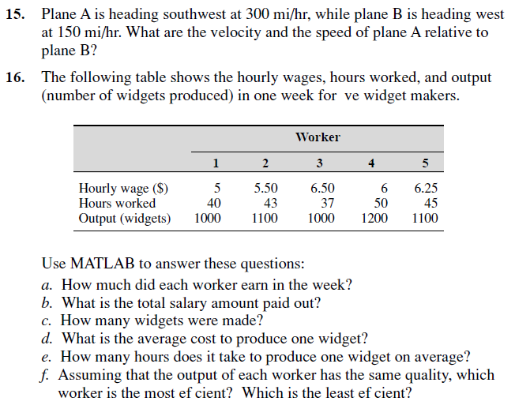

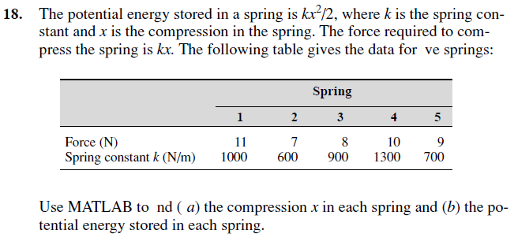

HW0223

1. 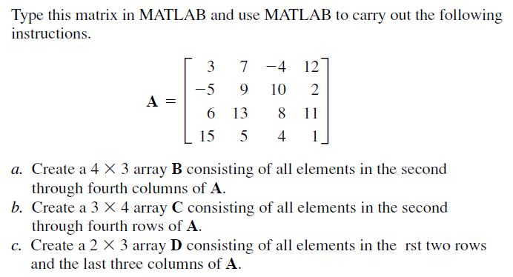

d. Please set the low bound of the matrix A to be 0. Hint: use the command ‘find’ to find the address of the matrix elements less than zero.

1. A company must purchase five kinds of material. The following table gives the price the company pays per ton for each material, along with the number of tons purchased in the months of May, June, and July:

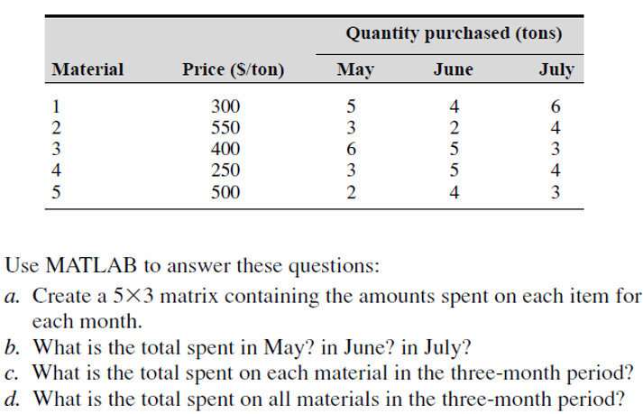



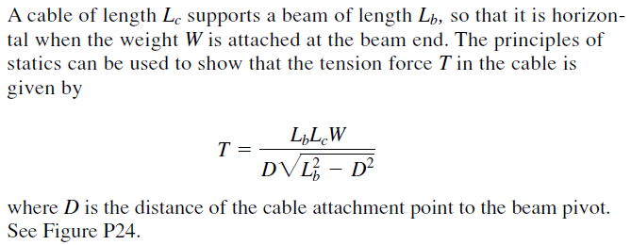

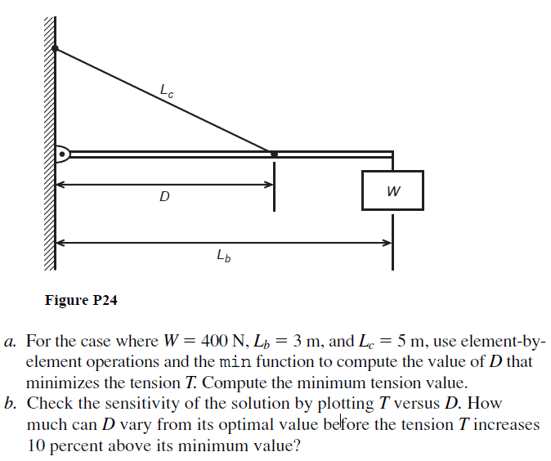

1. The following equation is a special case of one model used to describe the blood pressure in the aorta during systole (the period following the closure of the heart’s aortic valve). The variable *t* represents time in seconds, and the dimensionless variable *y* represents the pressure difference across the aortic valve, normalized by a constant reference pressure.

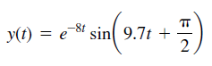

Plot this function for *t>* 0.



